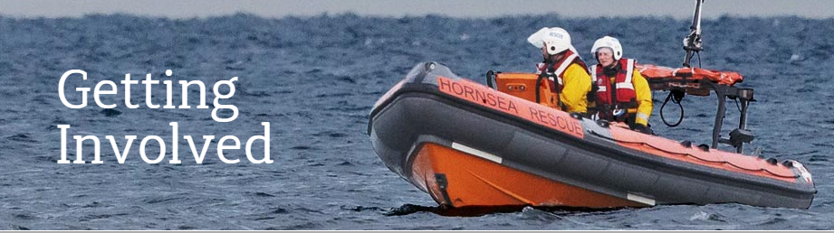

Hornsea Inshore Rescue
Volunteer Recruitment

Hornsea Inshore Rescue is a Registered Charity established in 1994 with the aim of preserving lives through the provision of a volunteer lifeboat service and raising awareness through training in water safety. We are looking for volunteers to join the Lifeboat Crew and support our general operations. Our volunteers are a vital part of what we do, and a challenging and exciting role if you are looking to serve your local community and save lives.

Lifeboat Crew Volunteer
If you are looking to serve as part of our Lifeboat crew, there are a few things that we need from you, and a few things we are willing to offer our volunteers in order to help them work effectively within our team.
Click here to go to application form

Boathouse Volunteers
If you have the time and passion to support our work, we can discuss a suitable role that matches your interests and abilities. Agreed duties could be within the boathouse, the community or on a computer at home. Giving just a few hours a week will make a lot of difference.
Click here to go to application form

Once completed, please return this form to: Volunteer Applications, Hornsea Inshore Rescue, The Boat House, Hornsea Burton Rd, Hornsea, East Riding of Yorkshire, HU18 1TJ or email info@hornsearescue.org.uk
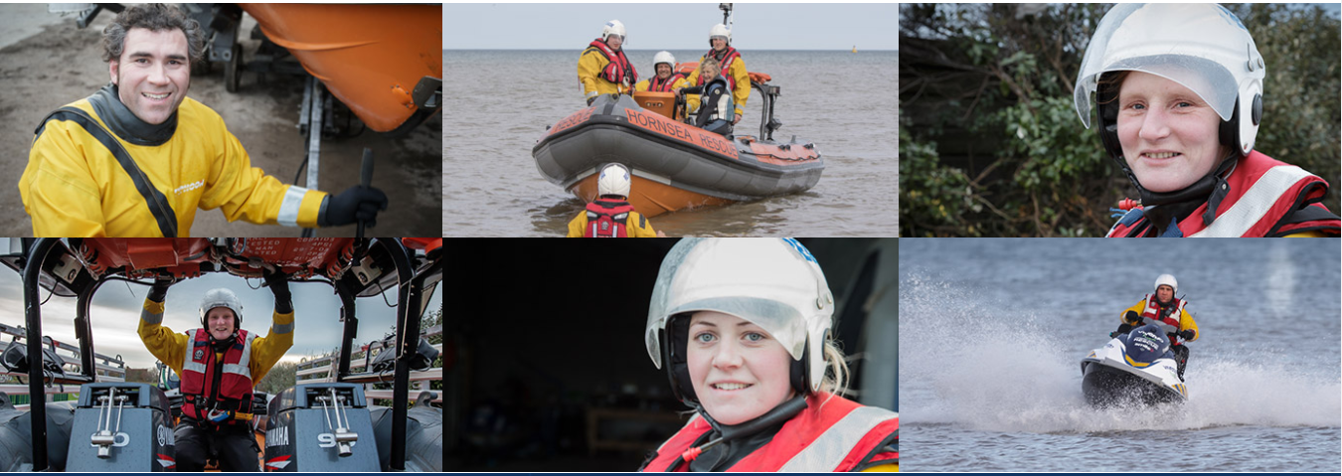

Boathouse Volunteer Application Form.

Name

Date of Birth

Gender

Address (incl. Post Code)
Phone No
E-mail
Best availability during the week?

Interests/experiences | Office/Customer Service |  | Fundraising
 | Marketing/Promotions |  | Events
 | Retail |  | Helping others
Other interests and/or experiences?

How did you hear about this opportunity?

Why do you want to volunteer for Hornsea Inshore Rescue?

Please tell us about any relevant experience?

Do you have any unspent convictions (incl. motor offences)? If yes, please give brief details.
Reference (please provide contact details for at least 2 references, one being your current/most recent employer) | Referee 1 |  | Referee 2
Having a criminal record will not necessarily bar you from volunteering with us. This will depend on the position applied for and the nature of your offence. If you are applying for a position involving regular contact with children or vulnerable adults you will be required, at the offer stage, to apply for an Enhanced DBS check.
Once completed, please return this form to: Volunteer Applications, Hornsea Inshore Rescue, The Boat House, Hornsea Burton Rd, Hornsea, East Riding of Yorkshire, HU18 1TJ or email info@hornsearescue.org.uk

Hornsea Inshore Rescue
Volunteer Lifeboat Crew – Role Description

What We Need From You:
Age: Must be over 18.
Physical Fitness: You need to be able bodied and have a reasonable standard of fitness. We require all of our volunteers to undergo a basic medical assessment from a qualified doctor.
Swimming Ability: Although not essential you would find it beneficial to be able to swim and be comfortable in the water.
Availability: We would need you to be available for a call out for at least one 24 hour period every week. You would need to live within a few miles of the Boat House as we would need you to be able to reach us within 10 mins of a call out being issued.
Training and Experience: No experience or training is needed, although if you have any that would obviously be of benefit to us.
Flexibility: As a small, volunteer-led team we need everyone to chip in with a little extra time and effort when required. We’d need you to be willing to step in if needed for any extra activities we organise, such as fundraising events/information evenings.

What We Offer:
If you are recruited as a volunteer crew member, Hornsea Inshore Rescue will provide the following:
Training/Support: An induction and all the necessary training and support you need to fulfil the role of volunteer crew member. This will include regular meetings to discuss your role and how you are doing.
Equipment: Suitable equipment to allow you to fulfil the role well and be suitably protected in what can be harsh weather conditions.
Clear Responsibilities: Ensure you have a clear idea of your responsibilities, including the time commitment required and the difference your role makes to the team.
Clear Communication: Fair, honest and timely feedback on your work

Volunteer Lifeboat Crew Application Form.

Name

Date of Birth

Gender

Address (incl. Post Code)
Phone No
E-mail
Availability
(Daytime Mon-Sun 0800-1800)
(Nights 1800-0800)
Occupation/Employer

Is your Family/Employer Aware of this application?
Are you Fit and Healthy?

What is your travel time to the Boat House | Heavy Traffic | Light Traffic
Do you have a valid UK driving license?

How did you hear about this opportunity?

Why do you want to be part of Hornsea Inshore Rescue’s Lifeboat Crew?

Do you have any relevant experience? (if yes, please provide details)

Do you have any unspent convictions (incl. motor offences)? If yes, please give brief details.
Reference (please provide contact details for at least 2 references, one being your current/most recent employer) | Referee 1 |  | Referee 2
Having a criminal record will not necessarily bar you from volunteering with us. This will depend on the position applied for and the nature of your offence. If you are applying for a position involving regular contact with children or vulnerable adults you will be required, at the offer stage, to apply for an Enhanced DBS check.
Once completed, please return this form to: Volunteer Applications, Hornsea Inshore Rescue, The Boat House, Hornsea Burton Rd, Hornsea, East Riding of Yorkshire, HU18 1TJ or email info@hornsearescue.org.uk

